IMC 446
FINAL ASSIGNMENT
TEMPO CASE STUDY
QUESTION 1:
EXECUTIVE SUMMARY:
Tempo Tea made its debut in 2000 but had to pause operations due to the COVID-19 pandemic. Since then, the market for RTD and functional beverages has become super competitive. Meanwhile, younger adults (21–34) who are more stressed than ever are shifting away from sugary sodas and high-stimulant energy drinks. Interestingly, 61% of CBD users are looking for calm and anxiety relief, highlighting a gap between drinks that work for both problems. Now, Tempo is stepping back to fill this void with its two products: a green tea blend designed for steady focus and a caffeine-free hibiscus blend for a soothing recovery. This creates an opportunity for Tempo to meet consumer needs that current RTD brands haven’t tapped into.

QUESTION 2:
INSIGHT TO OPPORTUNITY:
Revitalize Tempo by tapping into the idea that it keeps your focus sharp and your energy steady by easing stress throughout the day with its natural ingredients.

QUESTION 3:
MARKETING OBJECTIVES:
To increase sales by generating trial among mindful grinders.

COMMUNICATION OBJECTIVES:
To generate awareness that Tempo helps you stay balanced throughout the day by releasing stress without getting jitters or crashes.

QUESTION 4:
STRATEGY:
GET: Mindful Grinders
WHO: Are looking for natural solutions that boost both productivity and mental wellness, and
leans toward coffee or energy drinks to avoid midday slump.
TO: Make Tempo their go-to functional beverage for mental clarity and stress management
without any negative side effects of traditional energy drinks.
BY: Generating awareness that Tempo helps to relieve stress and gives a steady boost of energy that keeps you going without the jitters or crashes.

QUESTION 5:
KEY IDEA: #StayInSync

QUESTION 6:
CREATIVE:
INSTAGRAM POST 1:
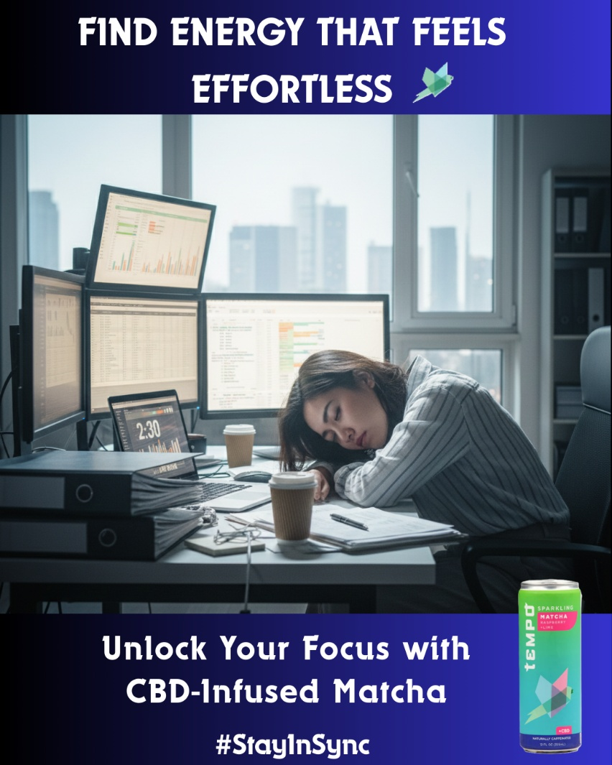

INSTAGRAM POST 2:



BILLBOARD:

